ACM DEVOPS TASK
Deploy a simple app to Kubernetes using a basic Helm chart. The chart should include a Deployment and a Service. First, show that the app is running correctly. Then, change the app to a broken version and upgrade it using Helm so that it stops working. Finally, use Helm rollback to go back to the previous working version and show that the app works again. Provide proof for all three steps.

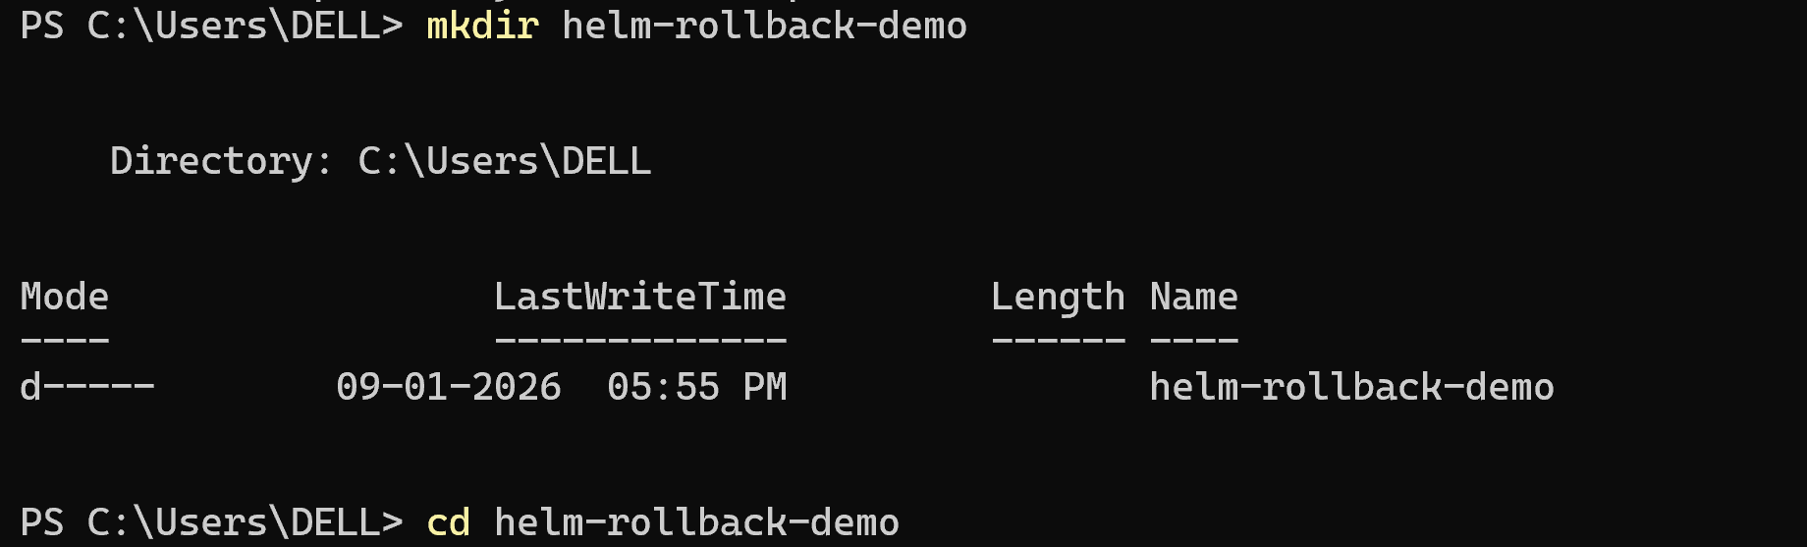
Creating folder for storing the files

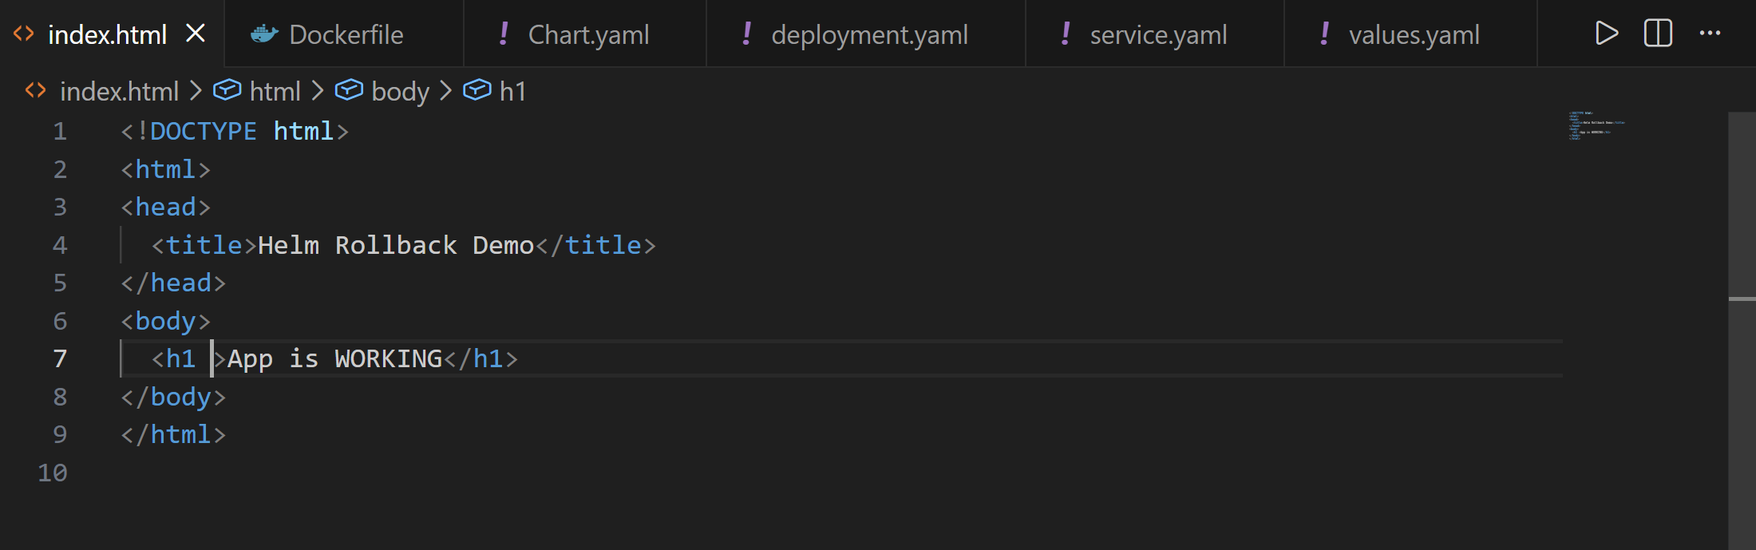
Adding the webapp(html only) to the created folder
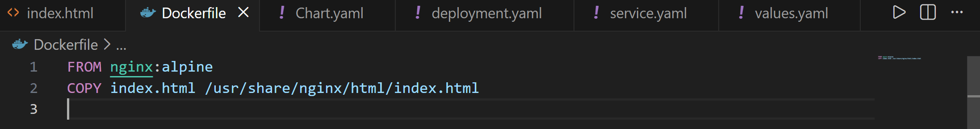
Adding the docker file for containerization of the web application

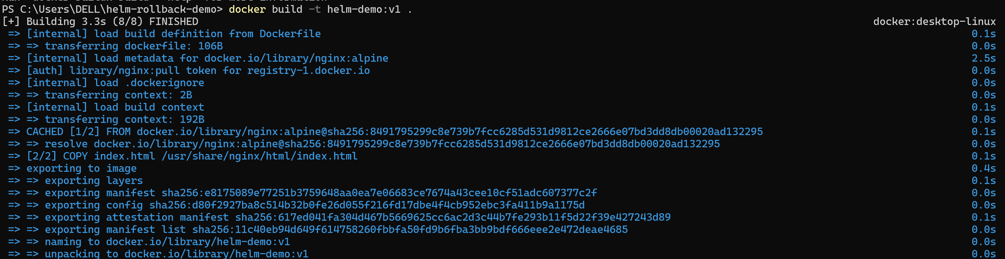
Creating a docker image using the instructions in the docker file

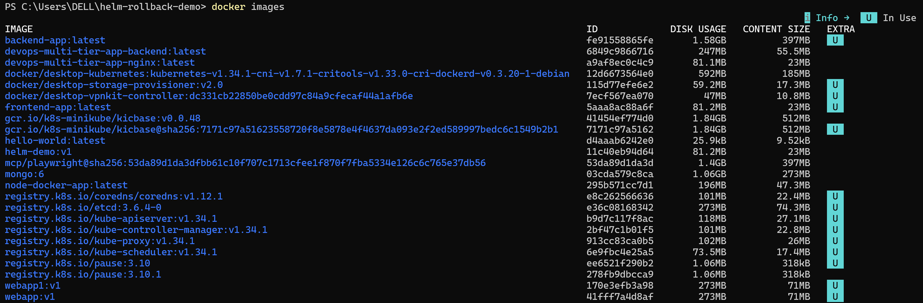verifying the created images – helm-demo:v1 exists

Using helm ,helm chart named webapp is created along with other basic k8s templates.

Change the directory to the helm charts and delete all the basic templates .

No create the Deployment and a Service .yaml files as asked .
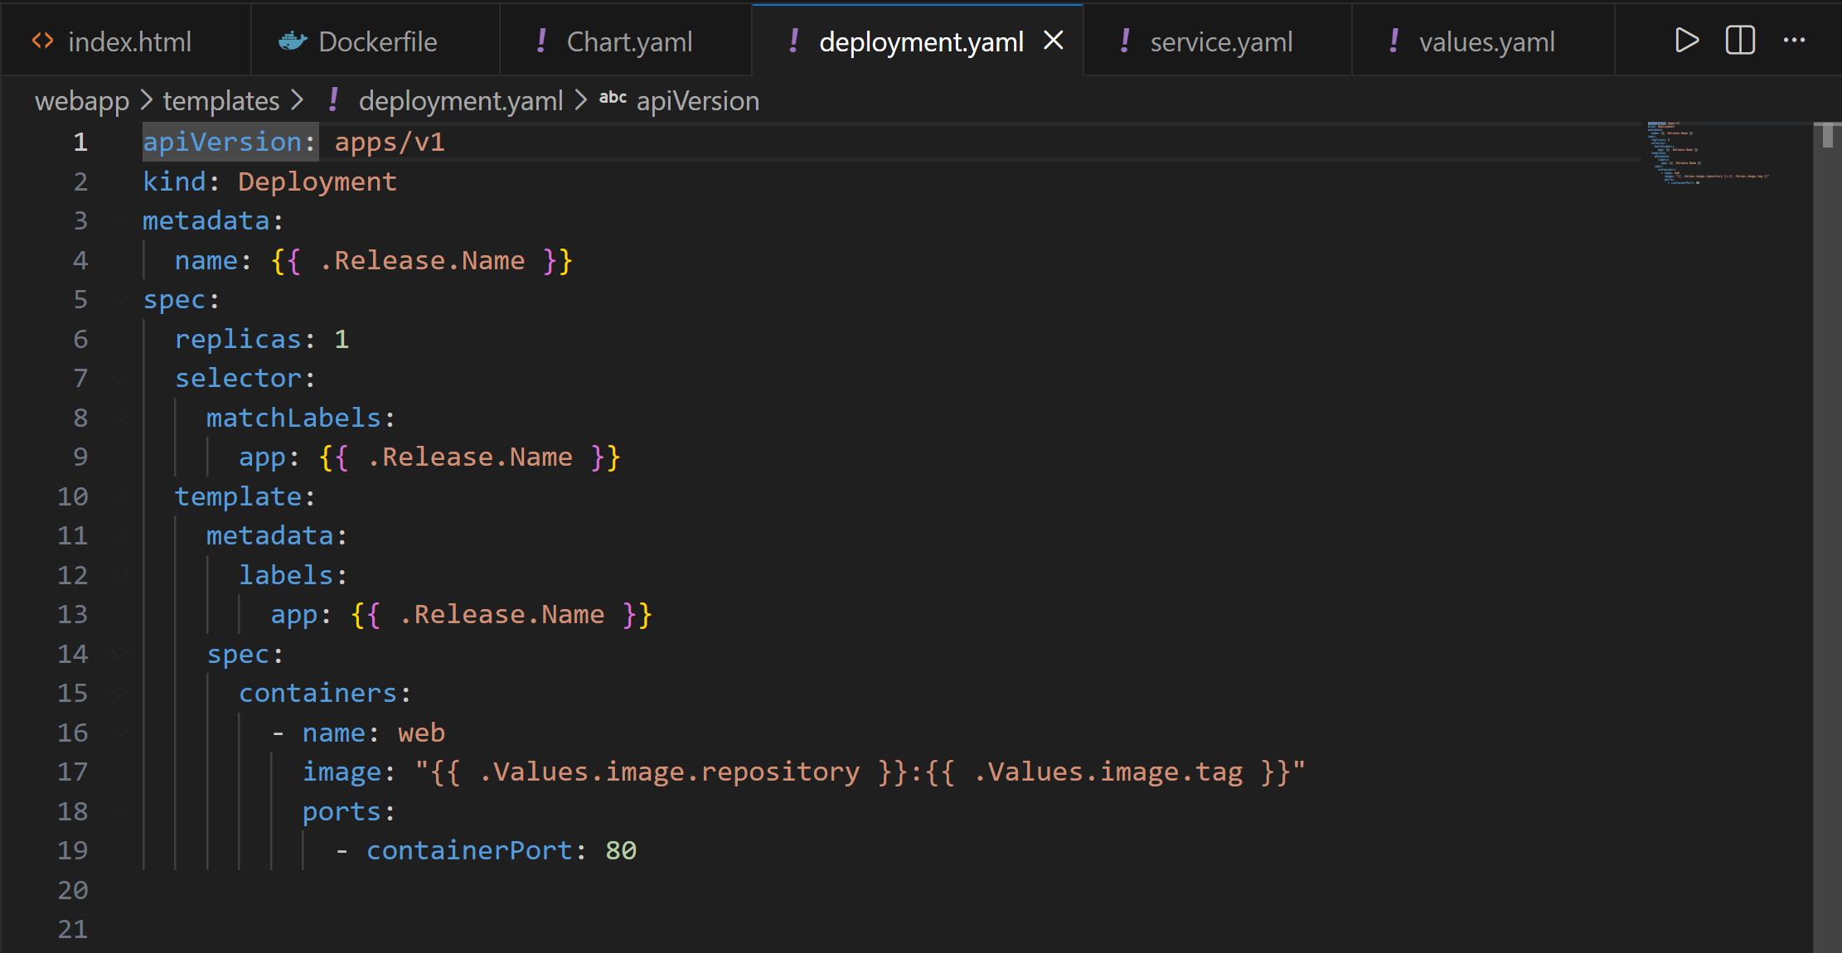
This contains the info that tell how the application runs .It includes the data like the which image to run,number of copies etc.
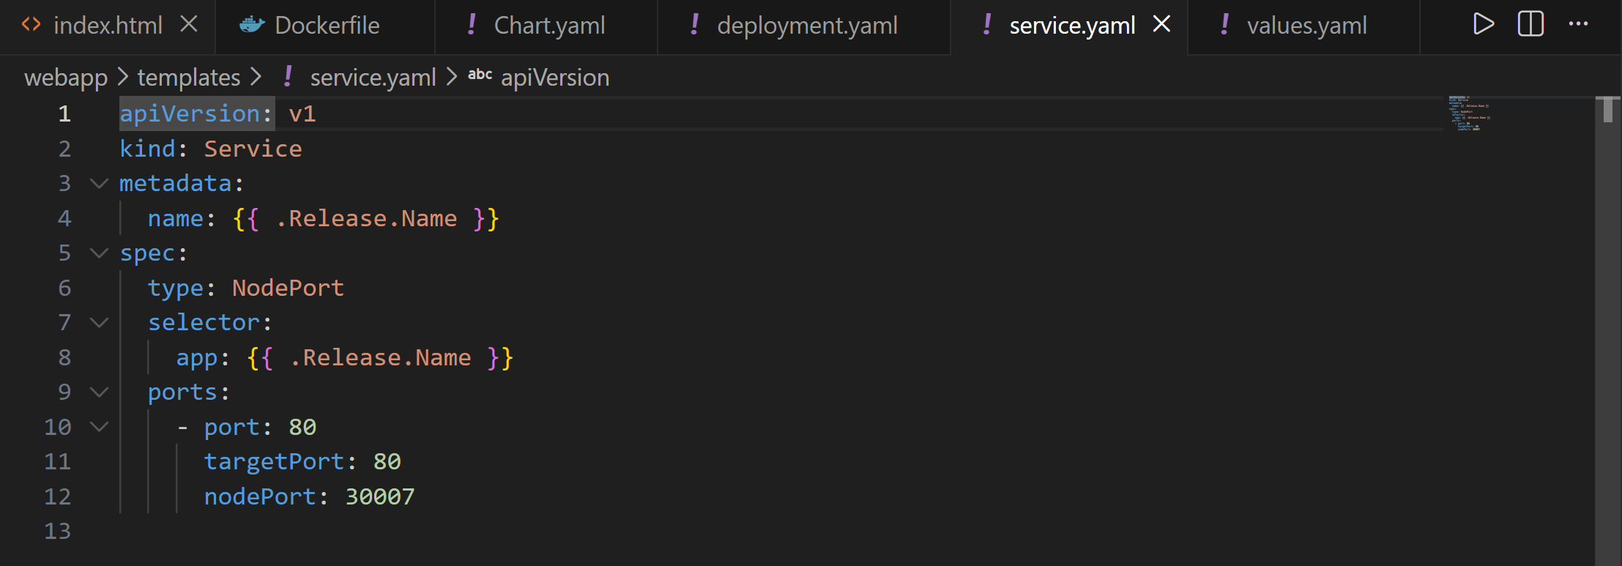
This contains the info about how the application is to be accessed like it has the port in which the web runs etc

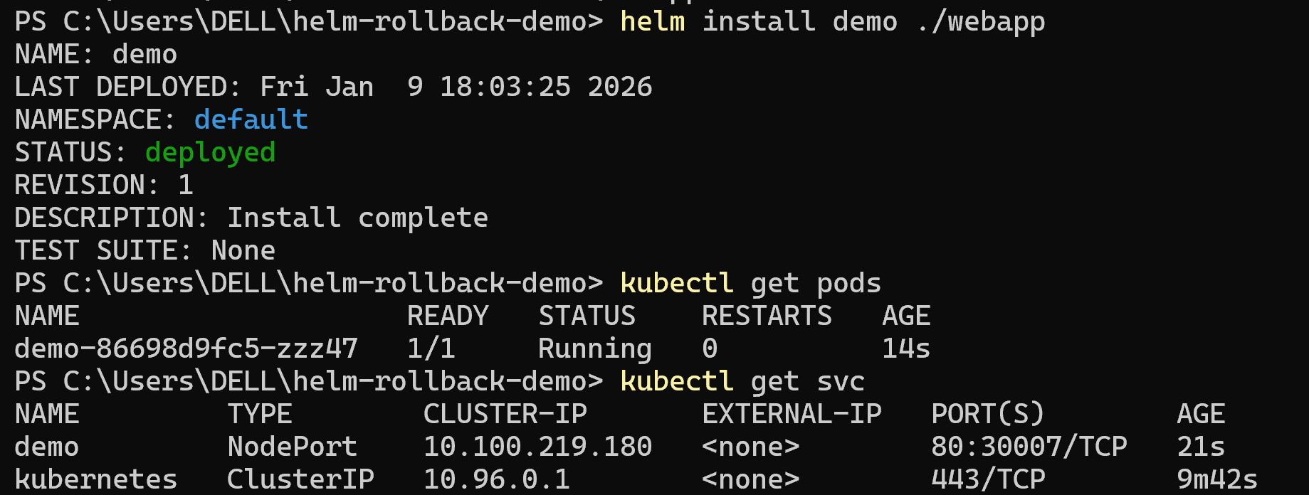
In this step helm goes through the charts.yaml ,values.yaml and in the deployement.yaml it replaces the line {{ .Values.image.repository }}:{{ .Values.image.tag }} with helm-demo:v1 and then this updated yaml is sent to k8s and then the objects are created.
This is one of the step that helm solves and saves time instead of updating the yaml files manually

This command shows the pod on which our application is situated and the status of it.

Now the website is up and running and can be tested be running it locally
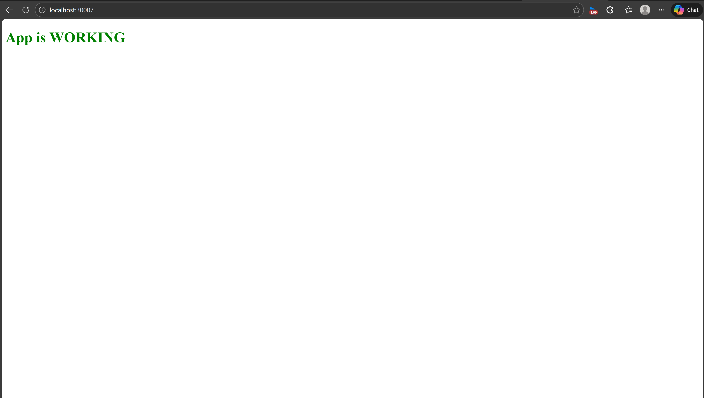

This shows that the process of deployment was a success.
Now to demonstrate the helm callback function we need to create some bugs such that it creates instability .
There are many ways to do this I have created some changes in the docker file so that the container crashes once it runs.
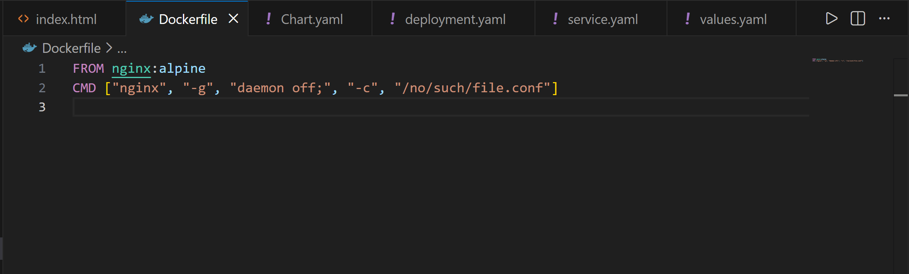
Now according to the updates docker file this will make It to run in a nonexistent config
Now we start the process of applying the updates
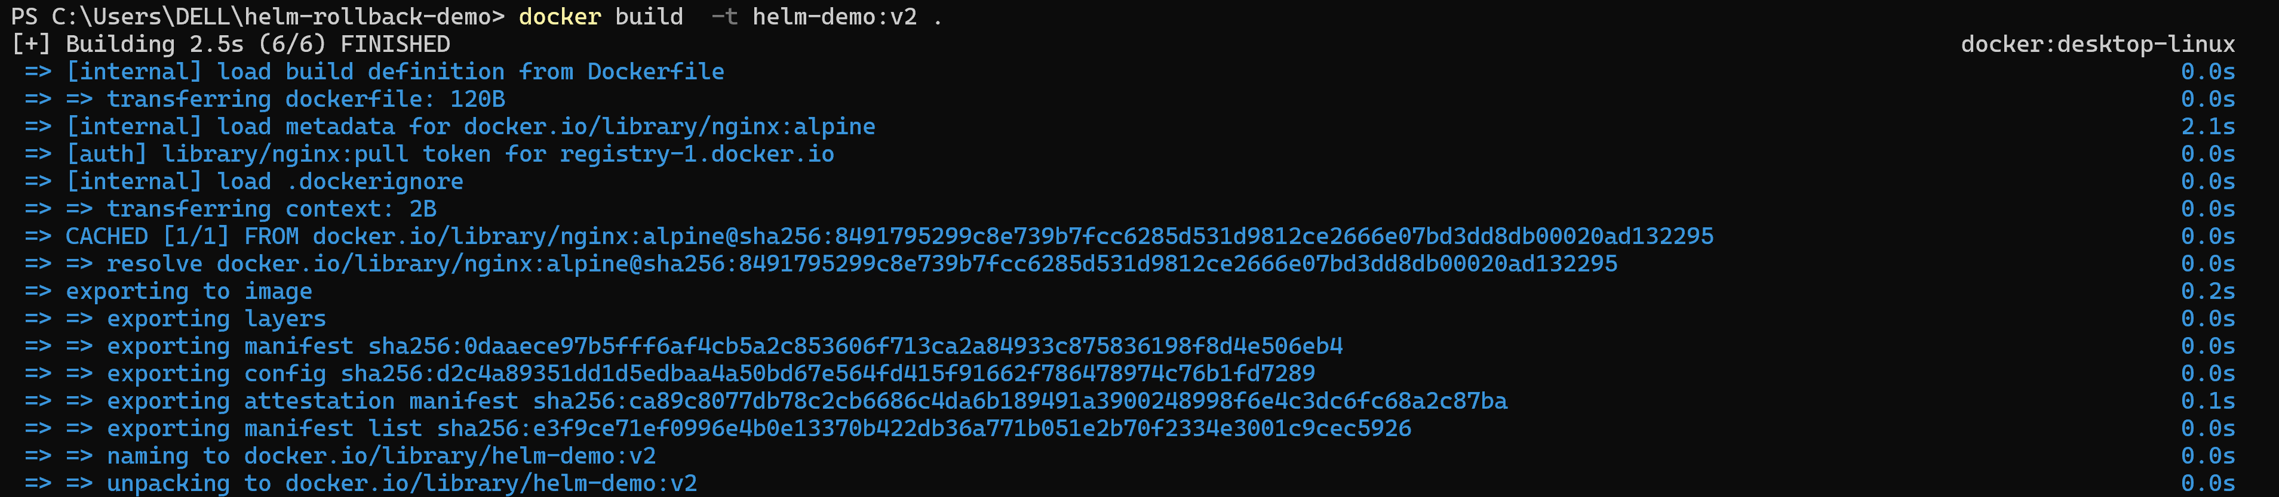
We start the process again from the build stage ,this builds a new image v2.
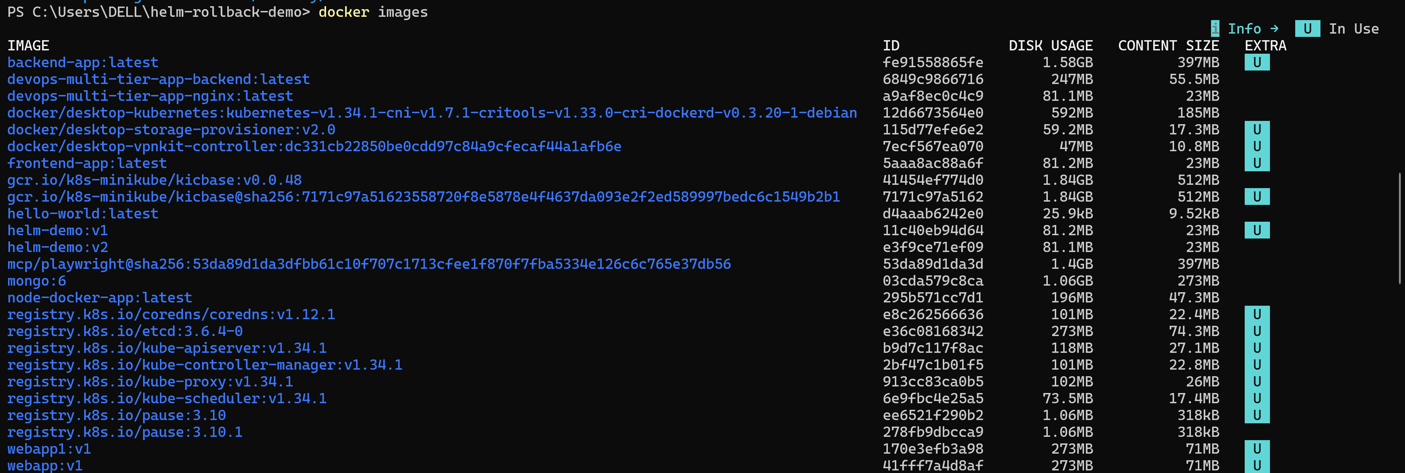
We can verify the images for helm:v2.

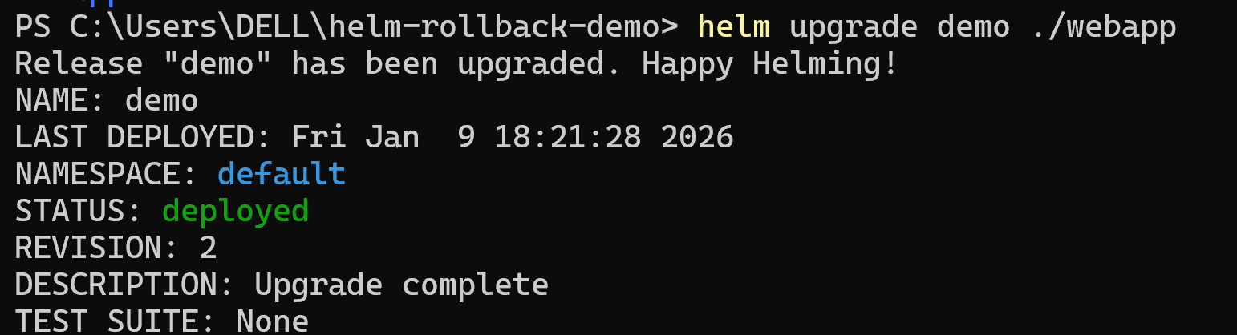
This upgrades the current version v1 with the changes in v2.

Now when we check to find on which pod is the v2 running we will get an error as planned
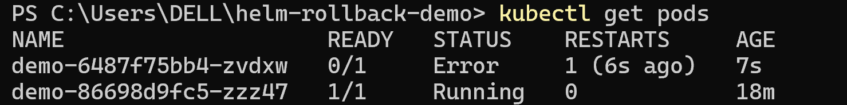

We can see that the pod is not running and the status is error.
We can run this command for describing the error.
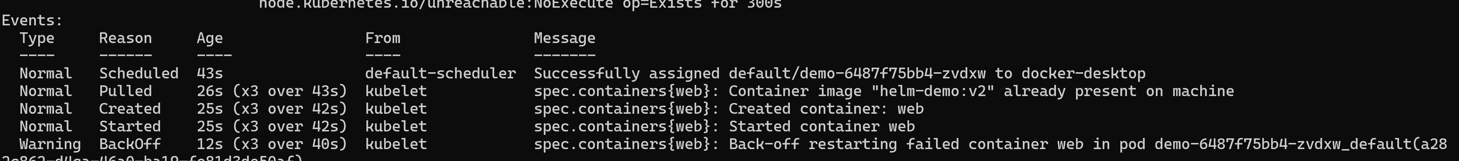
In the error we can see that the container has failed as we planned.
This is the time when we use the Helm rollback command
After running this command we can see that the roll back was success.
And when we check the status of the pods we can the the previous version is running on pod.
Using this command we can see the history of the changes that are applied in demo. And we can also see the description of each revision .

